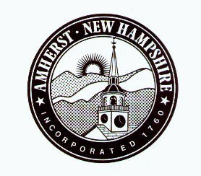

Town of Amherst, NH
BOARD OF SELECTMEN AGENDA

Village Streets Study Committee
Site Walk
Your input is very important! Please join the Village Streets Study Committee at the locations and times listed below for a site walk to the 5 Village Roads up for resurfacing (Carriage Road, Davis Lane, Main Street, Church Street, Jones Road).
Weather date if needed will be Tuesday October 17, 2023.

Sunday October 15, 2023
11:00AM – 11:50AM
Meet at the Village Common across from the Congregational Church to cover Church Street and Main Street.
12:00PM – 12:50PM
Meet at Carriage Road across from the library to cover Carriage Road, Davis Lane, and Main Street.
1:00PM – 1:50PM
Meet at Jones Road parking area for Wilkins sports fields to cover Jones Road.

